CE306 - Information Retrieval 2022
Assignment 1
1904341

Instructions for running your system
The first step of running the system is to start Elasticsearch. This can be done using the following command in a terminal window pointing to the Elasticsearch folder:
elasticsearch-6.5.1/bin/elasticsearch &
To run the Python program that does everything, run it in a terminal window using the following command:

python3 ass_1.py

Indexing
The dataset was downloaded from the provided link, but to post it to Elasticsearch it must be converted to a JSON first. Using an online tool I converted it into a format that Elasticsearch accepts. Some parameters on the website had to be tweaked for the output to be correct. The first was to only include the first 1000 lines:
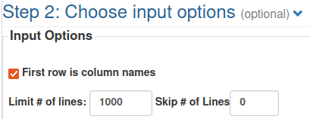

Then the output had to be tweaked, first by having every entry only occupy one line as well as omitting commas between the entries (This is in step 3 on the webpage):
Lastly I had to modify the template to create the output Elasticsearch wanted, with a index and id for each entry:
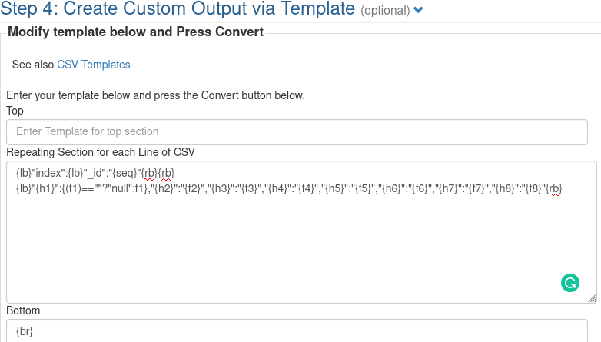
The first line created an index and id field above every entry. The {seq} was a built in function of the page that increments for every entry, so entry 1 has an id of 1 and so on. {lb} and {rb} are left and right brackets, while {br} is a line break, which is needed at the end of the file. {h1}, {h2}, etc. are the names of the column headers while {f1}, {f2}, etc. are the field values.

Using these settings, I created the file first_1000_movie_plots_deduped.json. This JSON file is automatically loaded and posted to Elasticsearch in the code.
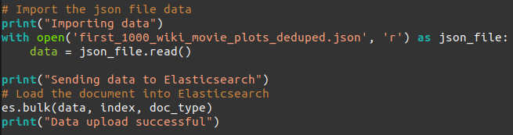
If no errors are thrown, the JSON file has been uploaded to Elasticsearch and is ready to be queried. In my testing there was never any problem uploading the JSON file.

Tokenization and Normalization
To do the tokenisation and case folding, I’ve created the following custom analyser:
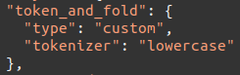
I chose to use the “lowercase” tokeniser as it divides the text into terms where it finds a character that isn’t a letter, but it also makes the terms lowercase. It does both the steps required, and does them more efficiently than if done separately.

All three of the analysers, as well as the implementation of the TF.IDF score and mapping it to the plot is contained in a single variable that is pictured in full on the last page of the report. This is passed to Elasticsearch at the start of the code:
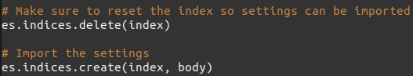
The second line deletes the index if it exists. The fifth line creates the index using the variable ‘body’, which is the previously mentioned variable.

Given the following sample input:
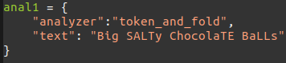
Using this method in the code:
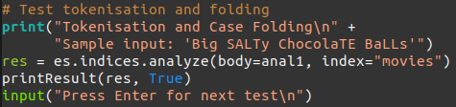
The analyser provides the following output:
It has turned every letter into lowercase, and separated the string into tokens.

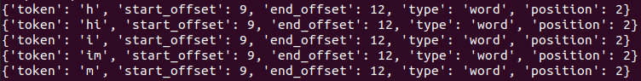
Selecting Keywords
To do the n-gram extraction and stop word removal, I’ve created the following custom analyser:
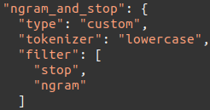
I decided to use the “lowercase” tokeniser for this analyser as well. This is because the stop word removal doesn’t catch stop words if they contain capital letters. I’ve also deliberately put the “stop” filter before the “ngram” filter because turning the input into n-grams means the words are split and the stop-word removal can’t do its job.

Given the following sample input:
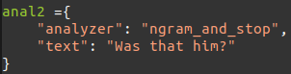
Using this method in the code:
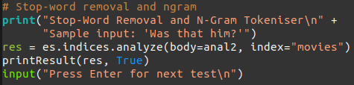
The analyser provides the following output:
It turned every letter into lowercase and separated them by none letter characters. Then it removed the stop words “Was” and “that”, and finally extracted 5 n-grams from the word “him”.
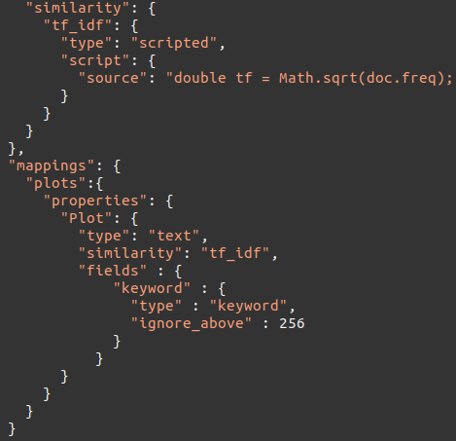
To implement TF.IDF scores, it must be created via script. Below is an adaption of the code to implement TF.IDF scores in Elasticsearch. I also map it to the ‘Plot’ field, as it makes the most sense to assign it there. The implementation was taken from: https://www.elastic.co/guide/en/elasticsearch/reference/current/index-modules-similarity.html:
The entirety of the TF.IDF script can’t fit on the screen, so I’ve pasted it below for convenience.

double tf = Math.sqrt(doc.freq);
double idf = Math.log((field.docCount+1.0)/(term.docFreq+1.0))
+ 1.0;
double norm = 1/Math.sqrt(doc.length); return query.boost * tf * idf * norm

The use of the TF.IDF score will be used for the searches later in the report.

Stemming or Morphological Analysis
To do word stemming, I’ve created the following analyser:
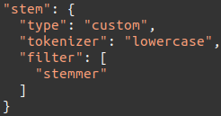
I once again chose to use the “lowercase” tokeniser, as word stemming won’t work as intended if words aren’t in lowercase. To do the stemming I’ve added the “stemmer” token filter.

Using it on the following sample input:
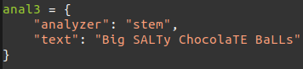
Using this method in the code:
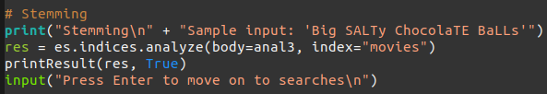
The analyser provides the following output:
It turned every letter into lowercase and separated the string into tokens. Then it reduced the words down to their stem.

Searching
The three textural queries I made up and created into Elasticsearch queries were created to guarantee hits in the limited dataset I chose to work on. They also vary in complexity.

The first textural query is what would be passed if someone wanted “Western movies”:
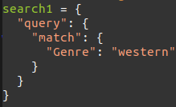
Using this method in the code:
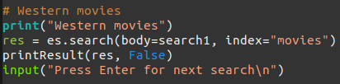
It provides the following output:
The search found 43 matches for the given query.

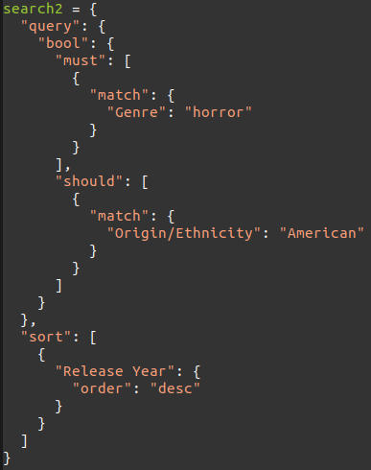
The second textural query is what would be passed if someone wanted “Horror movies that should be from America, but don’t need to be”. It is also sorted in descending order based on release year:

Using this method in the code:
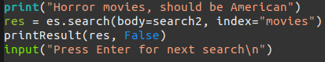
It provides the following output:
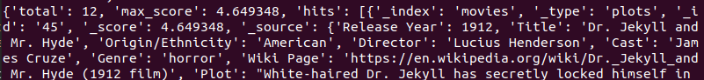
The search found 12 matches for the given query.

The third textural query would be passed if someone wanted “Movies where the plot mentions drama and was released before 1920”:
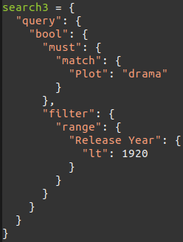
Using this method in the code:
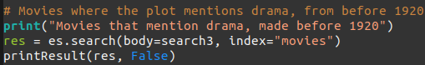
It provides the following output:
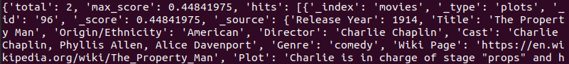
The search found 2 matches for the given query. The score for the two entries are also calculated using the TF.IDF script defined and mapped to the ‘Plot’ field.

Lastly, the ‘printResult’ function is something I wrote to not repeat code when printing the results. It looks like this:
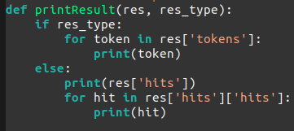
And here is the entire deceleration of the analysers, similarity module and mapping:
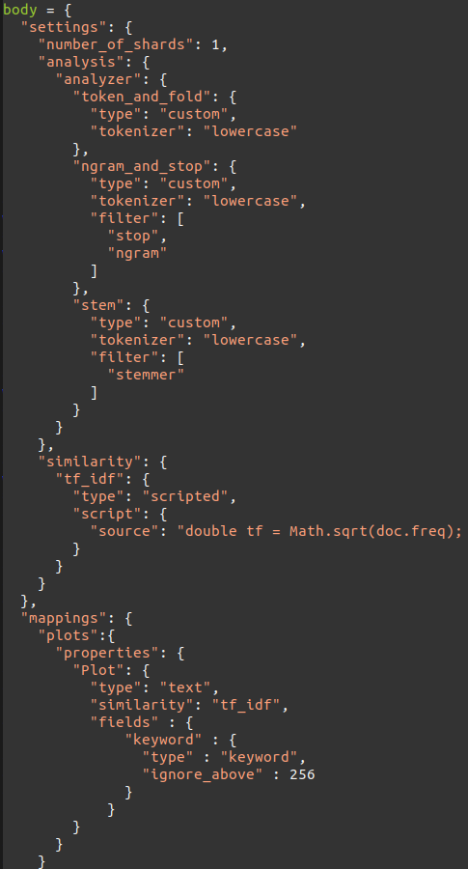

https://www.kaggle.com/jrobischon/wikipedia-movie-plots?select=wiki_movie_plots_deduped.csv
https://www.convertcsv.com/csv-to-json.htm

